Assignment 4 MailChimp link: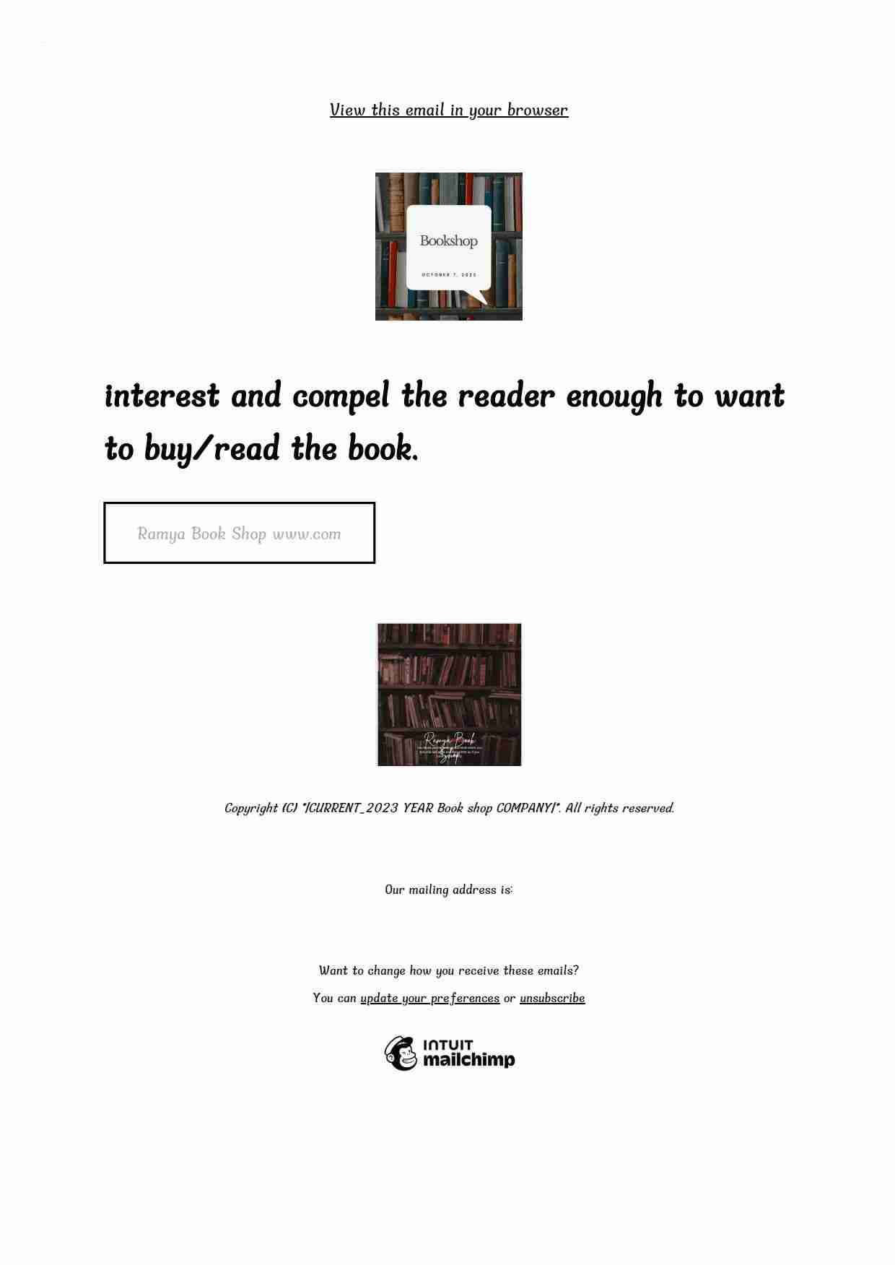https://eepurl.com/iB208Q